B1. Project setup and order form

Difficulty: Easy
Create a browser project using index.html, style.css and script.js and link the files correctly. Build an order form that captures customer name, product name, quantity, unit price, member status and delivery type. Include a clearly identified area where JavaScript can display messages and order results.

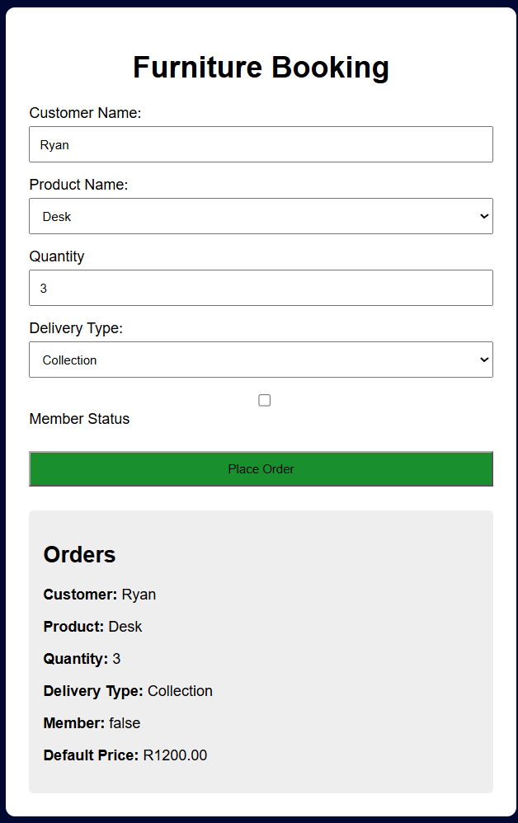
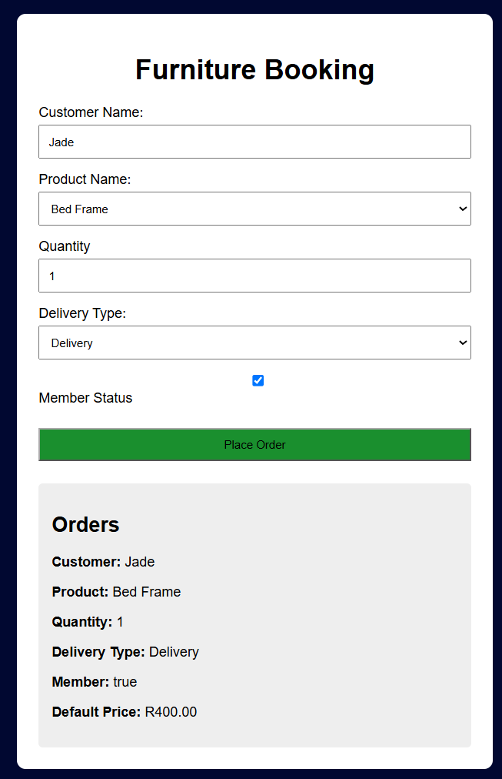

B2. Order calculation and summary

Difficulty: Easy
Read the values from the order form. Convert quantity and unit price to numbers before performing arithmetic. Calculate the subtotal as quantity × unit price. Apply a 10% member discount only when the customer is a member. Display a readable summary showing customer name, product, subtotal, discount amount and final total.
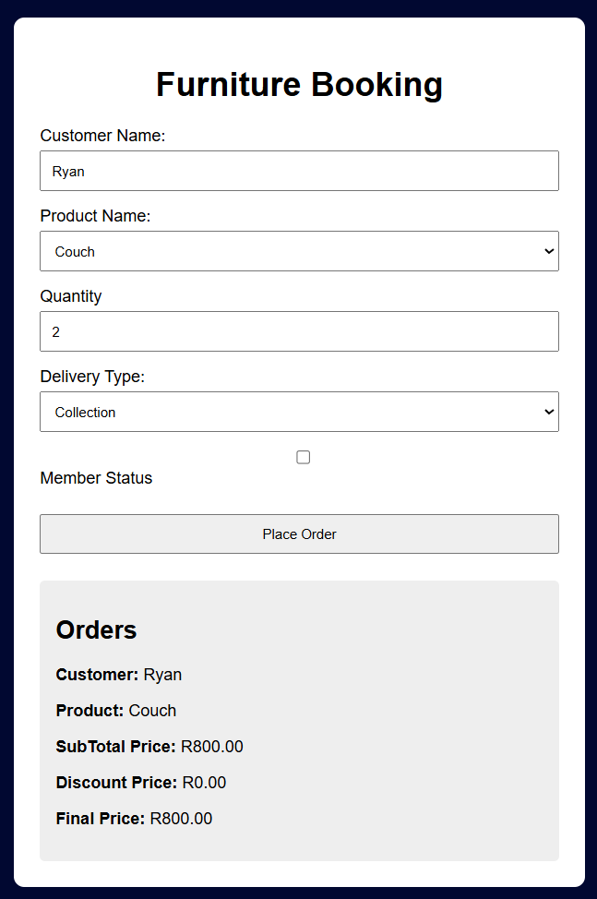
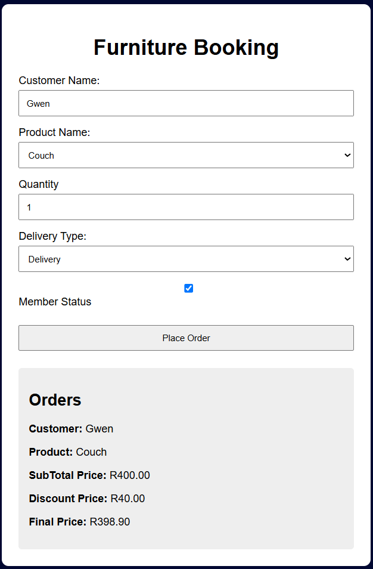

B3. Reusable calculation functions

Difficulty: Medium
Create a reusable function that receives quantity and unit price and returns the subtotal. Create a second reusable function that receives the subtotal and member status and returns the final total after the member discount decision. Use both functions in the order workflow. Your functions must return values rather than only writing directly to the page.

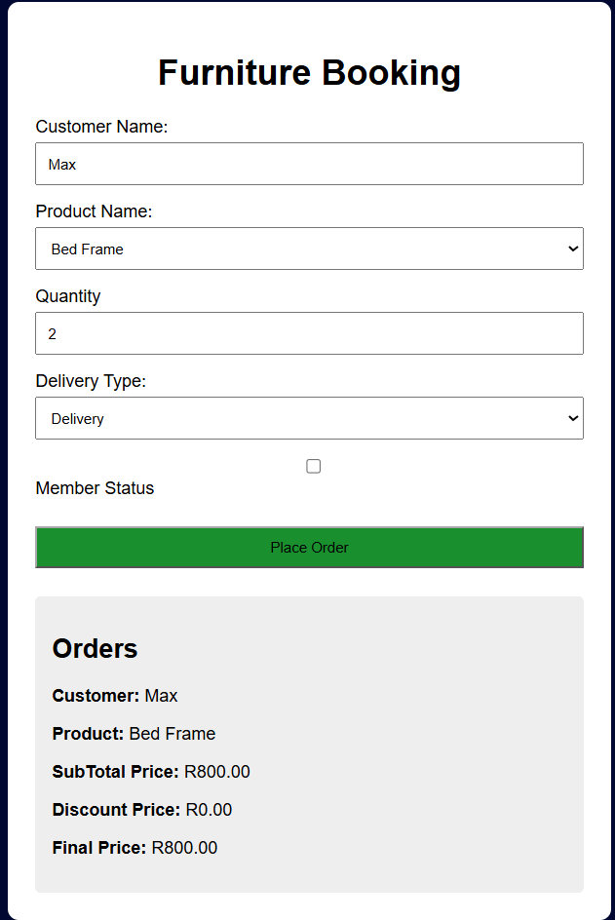

B4. Validation and form event

Difficulty: Medium
Handle the order form submit event in JavaScript and prevent the browser's default submission. Do not process the order when required fields are empty, quantity is not a positive whole number, or unit price is not a valid positive number. Display clear validation feedback using a text-safe DOM approach. When the data is valid, display a success message and continue processing
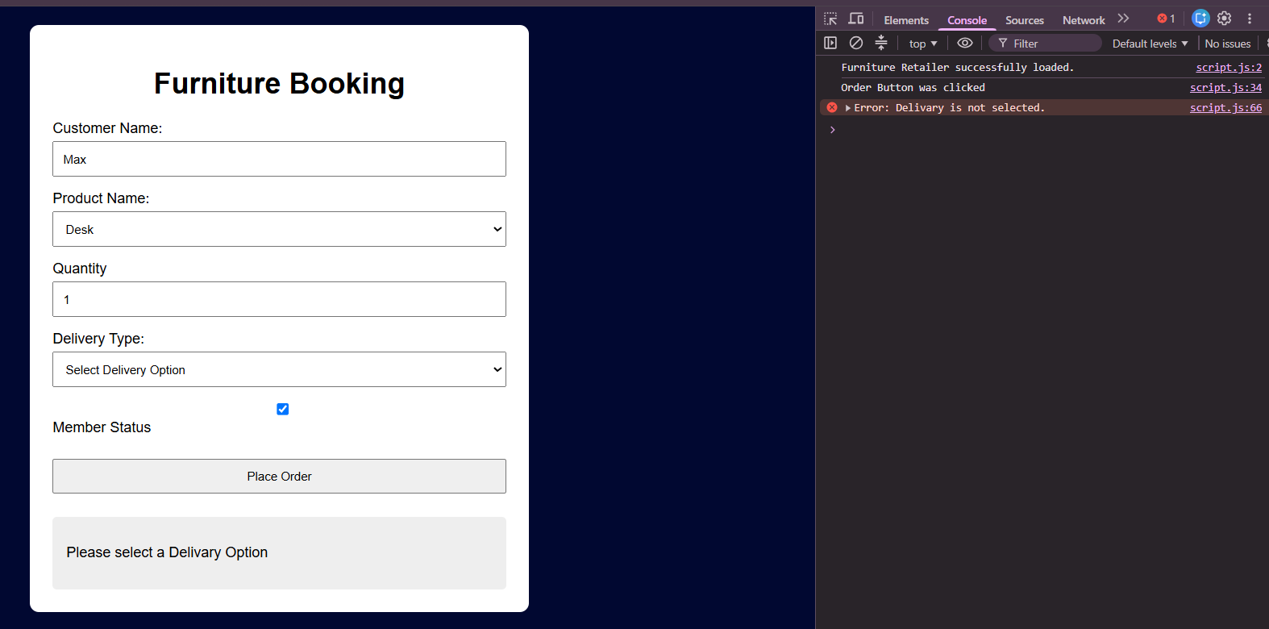
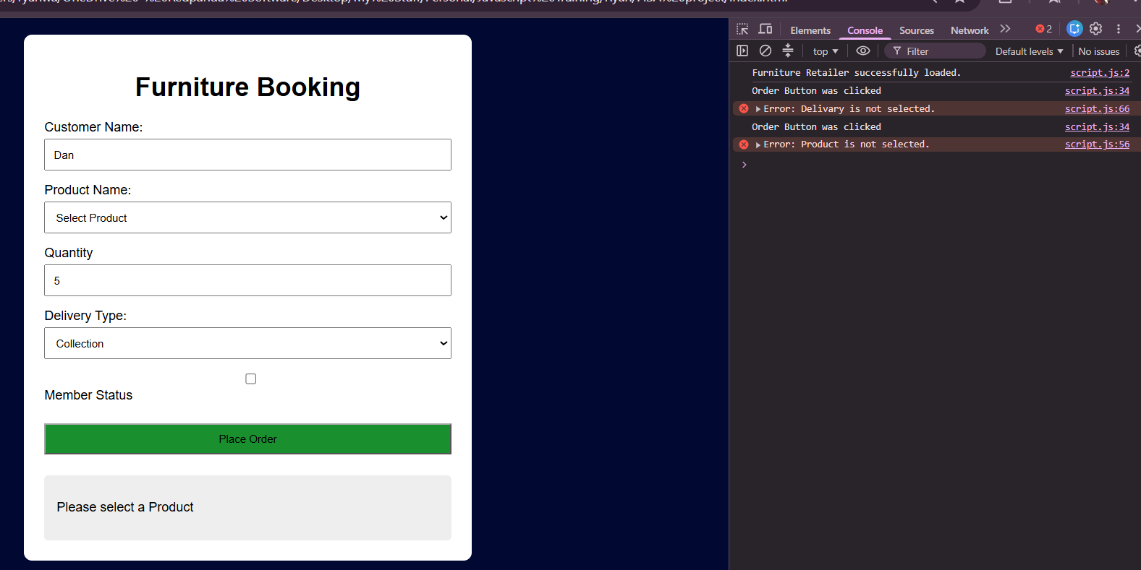
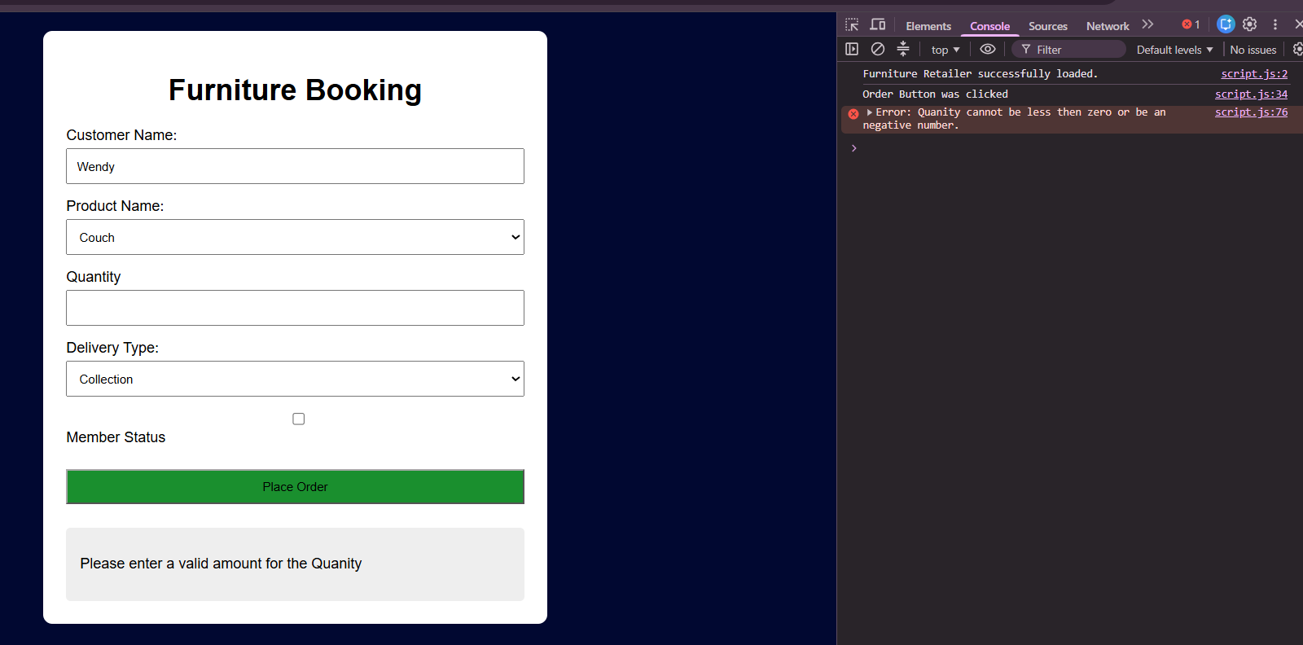
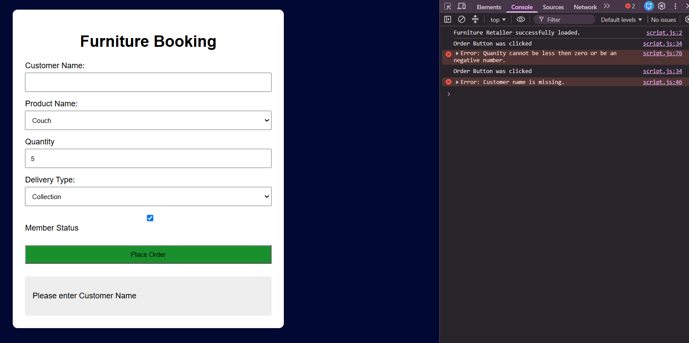

B5. Order records and status update

Difficulty: Hard
When a valid order is submitted, create an order object and add it to an orders array. Each order must include an id, customerName, productName, finalTotal and status. Display the orders on the page. Add a simple button next to each order that changes its status from Pending to Ready. Update the correct order object and then update the status shown on the page. It is sufficient for the button to perform this one status change.

B6. Order filtering, testing and debugging

Difficulty: Hard
Add a simple status filter that lets the user show All orders, Pending orders or Ready orders. Use the orders array to display only the matching records. Then use the browser console and at least one breakpoint or step-through action to inspect the order workflow. Run and record at least three tests: one normal order, one member order and one invalid order or status-filter case. Compare the expected and actual result and correct any defect found.

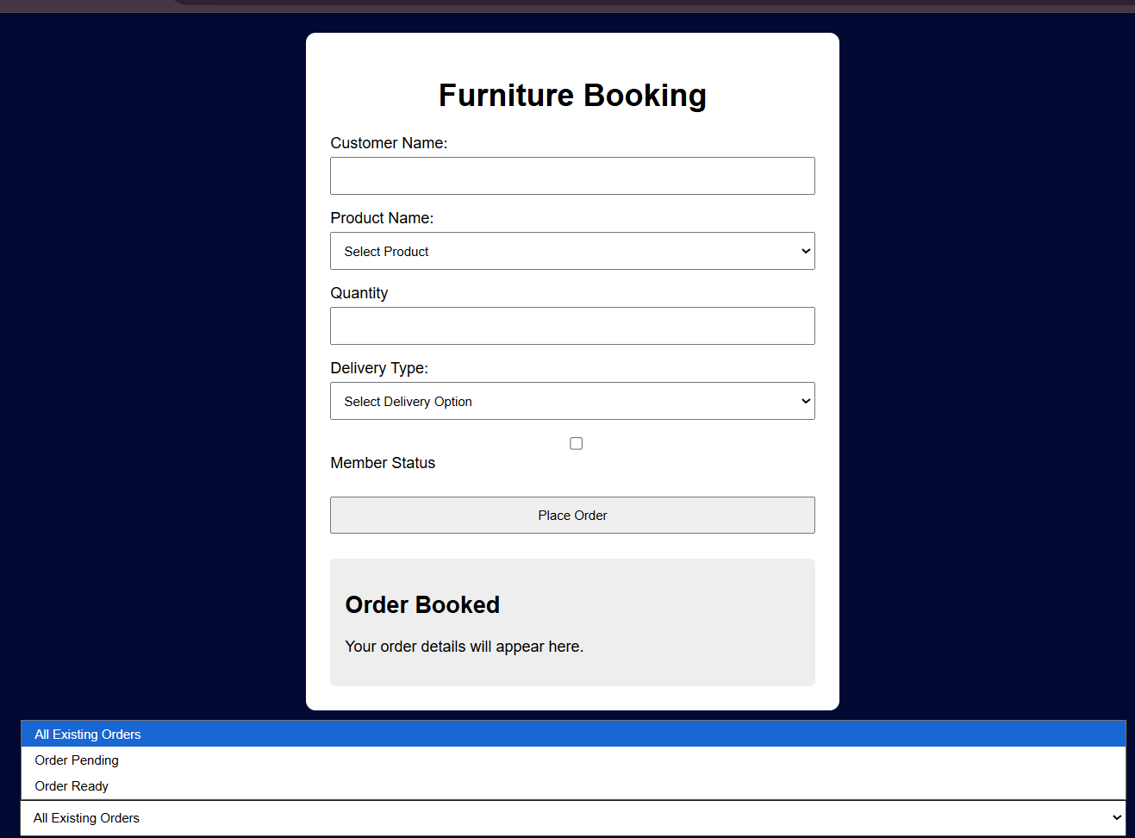

B7. Repository and README
Create a GitHub repository for the FISA project and add a README that briefly states the project purpose. [4 marks]

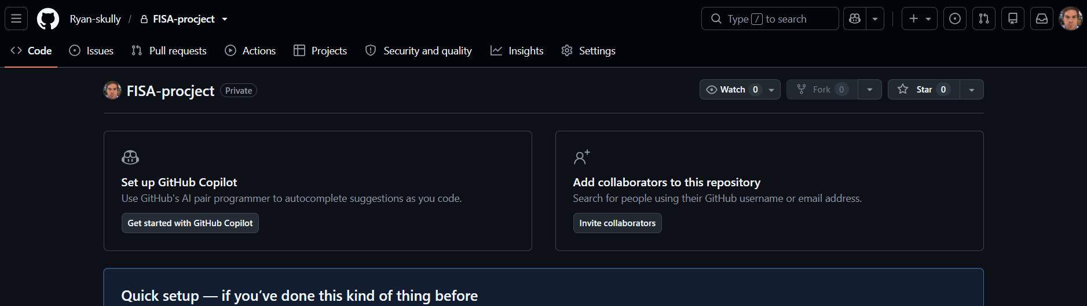

B8. Feature branch
Create and switch to a feature branch before making a new change to the project
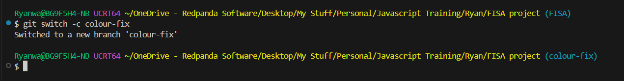

B9. Stage and commit
Stage a suitable change and create a commit with a clear message describing what changed.

